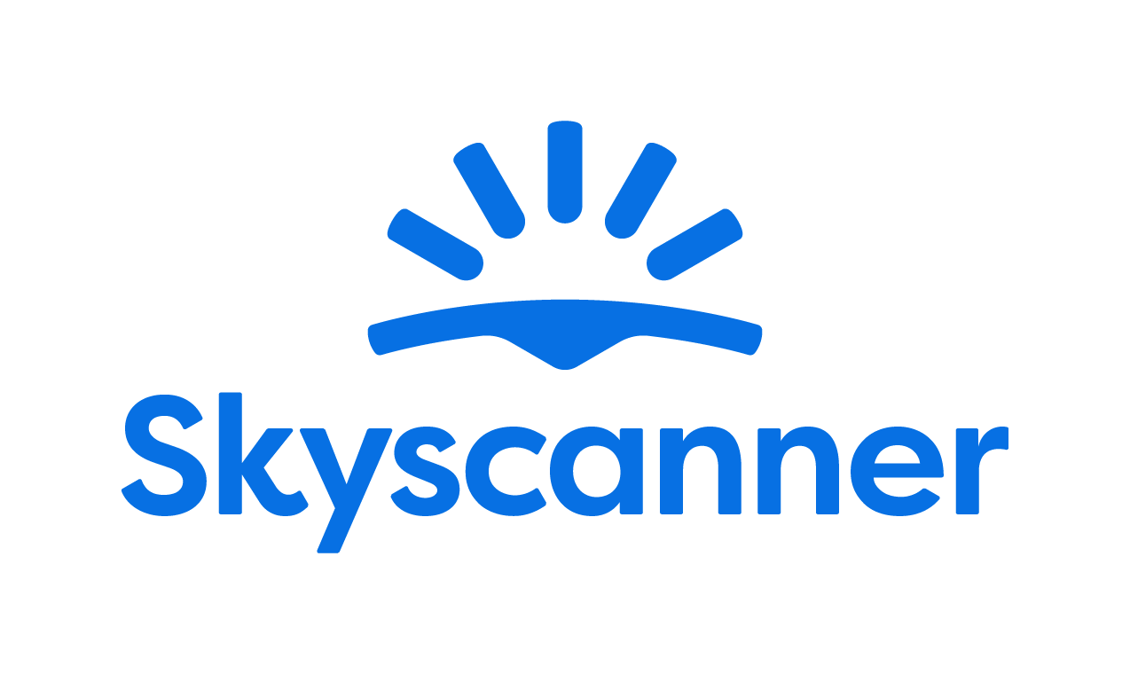

Localisation Style Guide

How to write and translate for Skyscanner in European Portuguese

1. Our Tone of Voice 4
1.1 Playful 4
1.2 Geeky 5
1.3 Helpful 6
1.4 Using the tone of voice in localisation 8
2. General writing and translation guidelines 9
2.1 URL requirements 9
2.2 Placeholders, variables and tags 9
2.3 Inclusive language 10
3. Language-specific translation guidelines
11
3.1. Punctuation and spacing 11
3.1.1. Commas 11
3.1.2. Ellipsis 11
3.1.5. Hyphens 11
3.1.6. Dashes 11
3.1.7. Full stops 12
3.1.8. Numbers 12
3.1.9. Currencies 12
3.2. Emphasis and intensifiers 12
3.3. References 12
3.4. Capitalisation 13
3.4.1. Titles and CTAs 13
3.4.2. Months and days 13
3.4.3. Capital letter after colon 13
3.4.4. Glossary terms / product names 13
3.5. The use of Anglicisms 14
3.6. Abbreviations and acronyms 14
3.7. Addressing our users – Formality and T/V policy 14
3.8. CTAs and active voice 15
3.9. Linguistic sequence 15
3.9.1. Transliteration 15
3.9.2. Geo-terms 15
3.9.3. Airport names 15
4. Cultural sensitivity 16
4.1. Emojis and symbols 16
4.2. Imagery 16
5. Translation guidelines per content type 16
5.1. User Interface (UI) 16
5.2. Marketing 17
5.3. SEO 17
5.4. Google Ads 18
5.5. App store 18
5.6. Editorial and blog posts 18
5.7. Emails and push notifications 19
5.8. Legal, Policies, Terms and conditions 19
6. Other Skyscanner specific guidelines 19
6.1. Use of Skyscanner brand 19
6.2. Feature naming 20
6.3. The use of “Best” 20
6.4. The use of “Discount” 21
6.5. Translating sustainability-related content 22
6.6. Accessibility guidelines 23
7. Useful resources and links 23

Our Tone of Voice

Skyscanner sounds like a Geeky Travel Pal. This means that:
- Our tone is playful
- Our energy is geeky
- Our message is helpful
Our brand promise is to be a helpful, honest travel ally. Our tone of voice should always support this:
- We give clear, useful information so travellers feel savvy.
- We are fair and transparent, so travellers feel confident and secure.
- We lead with empathy, so travellers feel valued and understood.
When localising, keep the same personality, but adapt expressions so they feel natural in your language and culture.

1.1 Playful
Our tone is playful. We write with a light, natural energy. Playfulness helps us feel human and builds trust – but it must never reduce clarity.
What playful means for us:
- A conversational tone, as if talking to a friend.
- A rhythm that feels lively, not flat or robotic.
- Turning travel frustrations into simple tips and “travel hacks”.
Example:
Instead of: Compare multiple airlines simultaneously and eliminate the need for multiple browser tabs.
We’d say:
Do | Don’t
Agora pode comparar preços de voos sem ter dezenas de separadores abertos. Tudo num único local. | Atenção: temos uma ferramenta de comparação de voos, para que encontre rapidamente as ofertas mais rápidas. Esqueça os múltiplos navegadores e separadores!

Use these tools when they feel natural and keep meaning clear (and when they work in your language):
- Rhyme – e.g. “As suas férias estão a chegar? Aproveite para poupar.”
- Alliteration – e.g. “Voos, viagens, viver algo novo.”
- Metaphors – e.g. “Os preços baixos são como as raposas. Assim que os vê, tendem a desaparecer de vista.”
- More vivid adjectives – e.g. “Fantástico” instead of “Ótimo”
Use these tools sparingly and only if they localise well:
- Puns (Nothing too obvious or too corny).
- Elongated vowels – e.g. “Saaaaaaaldos”.
- Interjections – e.g. “Ups! Oh, não! Uau!”
Always choose clarity over wordplay. If a device is hard to adapt or sounds unnatural in your language, do not use it.
Avoid
- “Fake-smart” corporate or management speak.
- Overly formal or stiff phrases.
- Trying too hard to be “LOL-funny”.

1.2 Geeky
Our energy is geeky: we love data, details and patterns – and we explain them in a human way.
What geeky means for us:
- We sound excited to share what we’ve learned.
- We show our travel expertise and curiosity.
- We break down complex information into simple steps.
Keep the tone enthusiastic but controlled. It should feel like a knowledgeable friend, not a lecture.
Instead of: We have the low-down on maximum baggage weight allowances across most major airlines so you can avoid fees and stress.
We’d say:
Do | Don’t
Passe pelo check-in num instante e sem taxas-surpresa. Temos os limites de bagagem de 137 companhias aéreas. | Quer curtir a sua viagem sem se preocupar com limites de bagagem?! Veja aqui INFORMAÇÕES COMPLETAS de 137 companhias aéreas!!!

1.3 Helpful

Helpful is our foundation. If you must choose between playful, geeky and helpful, be helpful first.
Our writing should:
- Make complex travel information simple.
- Make confusing situations clear.
- Make overwhelming choices manageable.
Instead of: Skyscanner has real-time data on the cheapest flights, based on the day of the week.
We’d say:
Do | Don’t
Precisa de saber em que dias é mais barato viajar? Nós ajudamos. | Se quer saber qual é o dia mais barato, não tem de descarregar muitas apps ou ver muitos sites! Não se preocupe mais. Estamos aqui para isso mesmo.

How to write helpfully
1. Put travellers first
- Focus on what they need to know, not on us.
- Start with the benefit or instruction, then explain how we know.
- Ask nicely - to help the traveller take action, they’ll be more inclined if we’re polite and respect their time.
Do | Don’t
Precisa de saber em que dias é mais barato viajar? Nós ajudamos. | Se quer saber qual é o dia mais barato, não tem de descarregar muitas apps ou ver muitos sites! Não se preocupe mais. Estamos aqui para isso mesmo.
Vai descobrir a opção mais barata entre milhares de voos | Nós pesquisamos milhares de opções de voos, para que beneficie dos melhores preços
A sua reserva foi confirmada | O serviço de viagem processou o seu pagamento e confirmou a sua reserva
Pedimos que envie as seguintes informações dentro de 48 horas, para tratarmos deste assunto | Tem de enviar estes dados nas próximas 48 horas

2. Be honest, upfront and take responsibility
When sharing bad news or apologising:
- Drop most of the playfulness.
- Always apologise if something is our fault. If it isn’t, show empathy instead.
- Be clear about what happened, what will happen next, and what we’re doing to fix it.
- Say sorry once, sincerely. Focus on solutions, not on how bad we feel.
- Avoid cold phrases like “We apologise for the inconvenience.
Do | Don’t
Infelizmente, a companhia aérea cancelou o seu voo. Sabemos que esta situação é frustrante para si, mas trataremos de obter o seu reembolso. | O seu voo foi cancelado pela companhia aérea. Vamos ver se conseguimos obter um reembolso.
Infelizmente, a companhia aérea cancelou a sua reserva. | Pedimos desculpa, mas a companhia aérea cancelou a sua reserva.
Lamentamos, mas ocorreu um erro e não é possível apresentar os voos disponíveis. Tente novamente pesquisar novamente ou volte a tentar mais tarde. | Desculpe, ocorreu um erro e não conseguimos mostrar-lhe as opções de voos. Lamentamos o incómodo causado.

3. Keep it short and simple
- Use short sentences and simple structures.
- Remove unnecessary words and repetition.
- Where you can, opt for the “pose question then offer solution” format.
Do | Don’t
Precisa de ajuda? Contacte o nosso apoio ao cliente. | Se necessitar de ajuda, telefone para a nossa equipa de apoio ao cliente.

1.4 Using the tone of voice in localisation
When translating or adapting content for Skyscanner:
- Keep the three qualities – playful, geeky, helpful – but express them in ways that fit your language and culture.
- Prioritise meaning and clarity over matching English phrasing.
- Replace wordplay (rhyme, alliteration, puns) with devices that work naturally in your language – or skip them if needed.
- Keep the friendly, human, travel-loving personality in every sentence.
Your goal: in every market, travellers should read the text and think,
“This sounds like a smart, friendly travel pal who’s genuinely here to help.”

General writing and translation guidelines

URL requirements
When translating or creating URLs for Skyscanner, follow these technical rules to keep URLs consistent, readable and safe across all markets. These are very important, since not following the guidelines may result in whole pages breaking and being unavailable for the audience.

- No spaces - If you need to separate words, use a standard hyphen -.
Do | Don’t
escapadelaurbana | escapadela urbana
escapadela-urbana

- All lowercase

Do | Don’t
escapadelaurbana  escapadela-urbana | Escapadela urbana  Escapadela-urbana

- No extended or special characters. Replace them with the basic Latin letter.
Do | Don’t
a, e, o, a | á, é, ó, ã

Placeholders, variables and tags
Placeholders, variables and tags are there to make the text dynamic (e.g. inserting a city, date or price) or to format it. They must not be translated, deleted or changed.

Always keep them exactly as in the source, placed in the correct order, and make sure the sentence is still natural and grammatically correct in your language. Make sure to insert spaces where needed before/after the tags to avoid words being glued together when the placeholders are populated.

In case the placeholder is not supported by the translation tool and shows as editable text instead of a tag, make sure not to translate the content but keep it as in English.

Example:
English: Search flights to @@city@@
Workaround: Pesquise voos com destino a: @@city@@

NOTE: When translating into Portuguese, placeholders are not necessarily placed in the same order. Depending on what they are going to be replaced with, you may have to rearrange them.

Example:

English: Your @@month@@ @@day@@ flight
Workaround: O seu voo de @@day@@ de @@month@@

Inclusive language
Our language should be inclusive, welcoming and respectful to all travellers. When translating for Skyscanner, avoid stereotypes, unnecessary references to gender, family, age, ability, or background, and choose wording that includes as many people as possible. Always prefer neutral, precise terms over clichés or labels.
- Use gender-neutral language where possible. When this is not possible, use the masculine form as the default form (as per Portuguese grammar rules).
- Do not assume who people travel with, how they look, or what they can do.
- Avoid jokes or idioms that rely on stereotypes about nationality, age, gender, religion, or any other group.
- Focus on travellers’ needs and situations, not on labels.
- In Portuguese, you must avoid, whenever possible, the use of the masculine form to address the user - it must make sense to both genders. Use gender-neutral forms.

Do | Don’t
Ótimo para grupos, casais ou quem viaja sem companhia | Perfeito para pais e mães com filhos
Ideal para quem procura um alojamento mais silencioso | Ideal para idosos que querem silêncio
Algumas ruas são bastante íngremes e podem ser mais difíceis de percorrer para pessoas com deficiência | Zona imprópria para incapacitados
Os restaurantes locais têm opções para todos os gostos | Restaurantes locais com opções para dietas normais e outras
Algumas opções que podem ser do seu agrado | Pode estar interessado nestes destinos

Language-specific translation guidelines

Punctuation and spacing
For general punctuation rules, please refer to Portuguese grammar rules. Please do not blindly follow the punctuation in the English source.

Commas
Apart from the general syntax usage, a comma should be used as a decimal separator (e.g. 10,5 milhas).
Do not use commas before “e” and “ou”, unless the subject is changed.

Ellipsis
After an ellipsis (...), the capitalization depends on whether it’s followed by a new sentence or continues the same sentence.
For example:
Estamos a preparar novidades… e vai sabê-las em primeira mão!
Em manutenção… Tente novamente mais tarde.
    - Exclamation marks
Use your best judgment to decide whether the sentence really needs to be an exclamation in Portuguese. Sometimes an exclamation mark can make a message seem forced or even ditzy, and sometimes a message can come across as too harsh or serious without one. The ultimate goal is for the target to sound natural and relatable to Portuguese users. Remember Portuguese tends to be slightly more formal, which means an exclamation mark in the source text doesn’t necessarily mean you should apply it.
    - Quotation marks
Always use straight quotes. The default is double straight quotes (""). If you need to use quotation marks within a quote, use single quotes ('').

Hyphens
Use a hyphen ( - ) to connect compound words and ranges of spans (without spaces).

Dashes
Use an en dash ( ⎼ ) for syntactic structures (with a space before and after). Only en dashes should be used.
Keyboard shortcut: ALT+0150.

Full stops
Apart from general syntax, please remember that full stops don’t always have to mirror the source text. For example, if the source sentence is too long, you can separate it into two or three different sentences with a full stop.

Numbers
Numbers 1 to 9999 should not use spaces.
Numbers 10 000 and higher need separators. For examples, 25 000, 1 000 000.
Use a comma for decimals (e.g. 12,5).

Currencies
Currency symbols should follow the number and a space (e.g. 10 €)

Emphasis and intensifiers
Sometimes we use formatting and wording to emphasise key information for it to be easy to spot, or as an intensifier for a part of the message. As a general rule of thumb, in your translations, you want to mirror that format if it makes sense in the target context (e.g. use of bold and italic format). Avoid using elements like all caps and multiple exclamation points.
Do | Don’t
Descubra o seu carro ideal 🚘 | Descubra o SEU carro ideal 🚘
 | Descubra o seu carro ideal!!! 🚘🚘

References
When you refer to other content (pages, features, sections, links), use clear, consistent names and, where relevant, the exact label used in the UI. Indicate the tools used in your language for references (quotation marks, italics…)
Do | Don’t
Clique no botão "Voltar aos resultados" para regressar à página de pesquisa e tentar novamente. | Clique no botão "Voltar para resultados" para regressar à página de pesquisa e tentar novamente.
 | Clique no botão VOLTAR AOS RESULTADOS para regressar à página de pesquisa e tentar novamente.

Capitalisation

Titles and CTAs
As a rule of thumb, we avoid title case and prefer sentence case, except for some Marketing and Ads content.
Use a capital letter for the first word and for any proper nouns and keep the rest in lower case.
For Portuguese, in titles, the infinitive form should be used. For CTAs, use the imperative form.
Do | Don’t
Reserve já (CTA) | Reservar Já
Como planear a sua próxima viagem com a Skyscanner (Title) | Planeie a sua próxima viagem com a Skyscanner

Months and days
Follow standard Portuguese rules for days of the week, days of the month and months. Some examples:
31 de outubro
31/10
Sexta-feira, 31 de outubro de 2025
In general, you should stick to the source form, but if you have space restrictions or character limits, you can use the short form.

Capital letter after colon
Colons should be followed by a lowercase letter, unless there is a line break. When in doubt, check the source document or look for possible tags that may indicate a line break.

Glossary terms / product names
Glossary terms and product feature names should follow a consistent capitalisation pattern across the product. Use sentence case for descriptive unless they are treated as branded names in your language.
Keep capitalisation the same in UI and running copy, and do not switch between different styles (for example, avoid mixing “Alertas de Preço” and “alertas de preço” without a clear rule).
Examples:
Saiba mais sobre o Drops
Explore em toda a parte em maio.
Encontre viagens para o seu orçamento com a opção Explore em toda a parte.
Defina um Alerta de preço para este voo.

The use of Anglicisms
Avoid unnecessary Anglicisms if there is a clear, natural equivalent in the target language. Only keep English words when they are widely used and expected by travellers (for example, brand names or common digital terms). Make sure any English term you keep fits the tone and formality of your market and stays consistent across the product.
Do | Don’t
Os 10 melhores destinos para 2026 | Top 10 de destinos para 2026

Abbreviations and acronyms
Use abbreviations and acronyms only when they are widely understood by travellers in your market (for example: airport codes, well-known transport terms). If there is a risk of confusion, write the full term on first mention and add the abbreviation in brackets. Avoid creating new abbreviations just to save space.
In Portuguese, do not add an “s” for plural forms.
Do | Don’t
Conheça as ONG que ajudamos | Conheça as ONGs que ajudamos

Addressing our users – Formality and T/V policy

In general, we aim for a friendly, respectful tone that feels like a helpful travel pal, not overly formal or distant. For Portuguese, you should use the formal tone (3rd person) for all communications. However, avoid using the word “você”. Apply it consistently across UI, marketing, emails and help content.
Do not use the informal “tu” unless the client explicitly asks for this.
Do | Don’t
Reserve já! | Reserva já!
Quando tivermos novidades, entraremos em contacto consigo | Quando tivermos novidades, você será contactado

CTAs and active voice
Use the active voice wherever possible, especially in headlines and CTAs. The active voice is usually clearer, and it sounds more like a direct conversation with our users.

- CTAs should be short, direct and written in the active voice.
- Use the imperative tense for Portuguese (in general).
- Focus on what the user can do next, using clear verbs and simple structures.
- Avoid long or vague phrases and avoid passive constructions where the user is not the clear subject.
- When adapting to each language, keep CTAs natural and action-oriented, in line with local expectations for apps and websites.

Do | Don’t
Reserve já | Quer fazer já a sua reserva?
Descubra o mapa | Descobrir o mapa
Veja os voos | Mostrar seleção de voos disponíveis

Linguistic sequence

Transliteration
Follow common local usage and official standards when transliterating place names, stations, and key travel terms. Be consistent within the language: don’t mix different transliteration systems in the same text. Do not invent new spellings or “localise” brand names that are normally kept in Latin script. If there is an established local exonym (well-known local version of a place name), use that; otherwise use the standard transliteration.

Geo-terms
Use the official or most widely used local names for countries, cities, regions and airports, and keep them consistent across all content. Avoid outdated, politically sensitive or rarely used forms, and don’t over-translate when travellers expect the original name (for example in airport names or well-known landmarks).
You can check this page from the European Union for the official names of countries, capitals and currencies in Portuguese:
https://style-guide.europa.eu/pt/content/-/isg/topic?identifier=annex-a5-list-countries-territories-currencies

Airport names
When translating airport names, refer to the official sources to make sure the name is correct.
Never add the word “airport” when translating an airport name to avoid duplication; it’s usually used to populate placeholders in a running copy, and the term “airport” is added to the copy when needed.
Example:
Fly from @@airport-name@@ Airport
Do | Don’t
Paris Charles de Gaulle | Aeroporto Paris Charles de Gaulle

Cultural sensitivity

Emojis and symbols
- Use emojis and symbols sparingly and only where they support clarity or add a light, on-brand touch.
- Make sure they are universally understood and appropriate in your market.
- Avoid replacing key words with emojis, and never use emojis in legal, policy or serious problem/incident messages.

When possible, replace any emojis or symbols present in the source copy if they are culturally inappropriate or the meaning is unclear in your market. When not possible/editable, flag the inappropriate content to Skyscanner and suggest a more suitable equivalent.

Imagery
Flag any imagery or references you encounter on Skyscanner product and other materials that could be seen as culturally inappropriate in your market (clothing, appearances, gestures, landmarks, food, family roles…)

Translation guidelines per content type

User Interface (UI)

- Be short, clear and action-focused. Prioritise clarity over playfulness.
- One idea per string; avoid ambiguity and extra words.
- Use the same wording consistently across product (e.g. always “Price Alerts”, not sometimes “Price Watch”).
Do | Don’t
Ver ofertas | Veja as ofertas de voos fantásticas que temos para si!
Viagem guardada | Acabámos de guardar a sua viagem com êxito
Ocorreu um erro. Tente novamente. | Ups… Não funcionou, mas não sabemos porquê.

Marketing
There is more room for creativity for Marketing content – we want the copy to sound natural, fluid and inspirational. Avoid sticking too close to the source text and make sure the translation feels like it has been created in the target language originally.
- Use the playful, geeky, helpful Skyscanner voice, but keep promises realistic and compliant
- Focus on traveller benefits: saving time, money, effort, or discovering new places.

Do | Don’t
Conheça Nova Iorque por menos. Temos opções que podem ser do seu interesse. | Reserve já os melhores voos para Nova Iorque.
Planeie a sua próxima escapadela urbana, com voos, alojamento e aluguer de carro numa só aplicação. | Selecione a origem e as datas para iniciar a sua pesquisa.
Seja uma praia perto de si ou uma ilha paradisíaca, temos várias opções. | Deixe-se surpreender pelos melhores destinos paradisíacos do planeta!

SEO
- Prioritise natural language, not keyword stuffing
- Write the way travellers actually search and think, while keeping our tone.
- Use clear, descriptive headings and titles
- Keep meta titles and descriptions concise and helpful

Do | Don’t
Compare voos baratos para Barcelona e veja datas convenientes para si. | Compare voos baratos para Barcelona e veja datas baratas e convenientes para si.
Viagens para Londres no fim de semana: descubra opções para estadias curtas | Experiências urbanas para consumidores com pouco tempo para Londres.
Pesquise e compare voos para Tóquio, filtre por companhia aérea, hora e escalas e fique a par dos preços. | O melhor lugar para encontrar ofertas incríveis de voos para Tóquio.

Google Ads
- Be very concise; use clear benefits and a direct call to action. There are usually strict character limits.
- Avoid clickbait and unprovable claims (no “#1”, “best”, “cheapest ever”).
- Avoid exclamation marks and other unnecessary punctuation.
- Use common search language that travellers would type.

Do | Don’t
Compare voos para Tóquio e poupe tempo. | Veja aqui os melhores dos melhores voos para Tóquio!
Descubra excelentes ofertas de voos para Roma. | Os voos mais baratos para qualquer lugar. É garantido!

App store
- Highlight main benefits and features clearly (search, compare, track prices).
- Use simple, natural phrases that work well in screenshots and previews.
- Avoid superlatives and guarantees.

Do | Don’t
Compare preços de voos, hotéis e aluguer de carros, na mesma app. | Nunca mais vai precisar de outra app de viagens.
Defina alertas de preço para saber quando estes descerem. | As melhores ofertas do mundo, sempre.

Editorial and blog posts
- Use a warmer, more descriptive tone, but keep it factual and practical.
- Balance inspiration with concrete tips (times to go, rough prices, how to get around).
- Adapt and localise content that isn’t relevant for your market

Do | Don’t
Para quem tem o orçamento um pouco mais limitado, é boa ideia procurar voos a meio da semana e evitar os feriados. | Viajar para este destino no verão é coisa de loucos. Aproveite a primavera ou simplesmente evite ir.

Emails and push notifications
- Keep subject lines short and clear, and body copy friendly, helpful and inspirational.
- Make it obvious what the traveller can do next (search, check a deal, manage a booking).
Do | Don’t
Há um novo alerta de preço para Londres | Esta oferta é inacreditável!!
Os voos de Lisboa para Londres nas datas que escolheu estão mais baratos. | É agora ou nunca. Estes são os melhores voos que vai encontrar.

Legal, Policies, Terms and conditions

- Prioritise accuracy, clarity and consistency over tone.
- Be precise and neutral; avoid jokes, idioms and emotional language.
- Do not add promises or interpretations that are not in the source text
Do | Don’t
Estes termos aplicam-se a todas as pesquisas e reservas efetuadas na nossa plataforma. | Estes termos geralmente aplicam-se à maioria das pesquisas e reservas.
Só garantimos a disponibilidade ou o preço dos voos quando a sua reserva for confirmada. | Nem sempre podemos garantir a disponibilidade ou o preço antes da confirmação da sua reserva.

Other Skyscanner-specific guidelines

Use of Skyscanner brand
The name Skyscanner is a core part of our brand identity and must be treated consistently across all languages. It should remain recognisable, correctly spelled, and used in a way that feels natural to the local audience while still protecting the brand.
When a transliteration may be used:
- Only in non-Latin alphabets where transliteration is common and already established for our brand
- When it improves readability in running copy and aligns with local norms
- Never translate or adapt the meaning of the name (e.g. never translate “sky” or “scanner”).
- Do not add articles unless they are required in your language and sound natural.
- If in doubt, always use Skyscanner in English and flag questions to Skyscanner.
- In Portuguese, use the feminine form (a Skyscanner).

Feature naming

When localising feature names, focus on meaning and user clarity, not on literal translation. A good feature name should be:
- Short and easy to scan
- Clear about what the feature does
- Natural and familiar in your language
- Consistent with terminology used by other travel providers in your market
Avoid direct, word-for-word translations if they sound strange, misleading, or carry unintended meanings. Only use the English name if it is already widely known and expected in your market.
Before finalising a name, check:
- How similar features are named by local travel providers
- Whether the term is already standard or commonly understood by travellers
- Whether the name could be misinterpreted
Example:
The English term “Packages” may be misunderstood as “parcels” in some languages, while we refer to a new vertical offering package holidays including flights and a hotel.
A clearer, more natural option in your language could be “package holidays” or the local equivalent travellers recognise.

The use of “Best”

Be careful with the use of “best” and superlatives in general. We are unable to claim that we can find travellers the “best prices” and “best deals” as this is an objective claim versus our competition that we would not be able to substantiate.

We can, however, use “Best” when there is a clear disclaimer explaining how "best" is measured.

Example:
Do | Don’t
Após uma pesquisa alargada, este é o melhor preço que encontrámos na nossa plataforma. | Este é o melhor preço para este voo.

Do | Don’t
Comparamos ofertas de voos para Paris e encontramos a solução que mais lhe convém. | Descubra os melhores voos para Paris.

For example, we can sort our flight results by “Best” results since we have a disclaimer clearly explaining how this is measured:

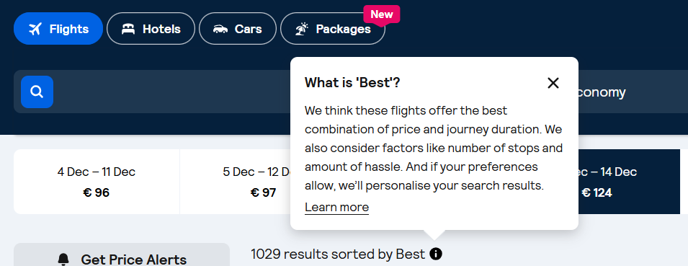

Generally, when the English copy says “best”, it’s safe to translate it the same way. When this is not the case, do not use “best” or other superlatives. Instead, use subjective claims such as “epic prices” or “amazing deals”.

The use of “Discount”

Skyscanner never offers discounts to users. Any discounts come from partners (for example Trip.com), not by Skyscanner.
For this and especially for legal reasons we can therefore never imply that “we offer” or “Skyscanner offers” a discount. This must be translated in a neutral way, i.e. “You are offered a discount”.

Never use the translation or equivalent of “discount” when the English source refers to a “deal” or “price drops” – these are not discounts but results of price fluctuation and it would be legally incorrect to refer to discounts.

Do | Don’t
A funcionalidade Drops mostra-lhe voos com uma redução de 20% ou mais no preço. | A funcionalidade Drops mostra-lhe voos com desconto de 20% ou mais.

Translating sustainability-related content
When localising content about anything related to sustainability for Skyscanner, it’s essential to communicate responsibly and avoid greenwashing. Travel has an undeniable environmental impact, and our language must reflect this honestly and transparently. Use the following principles when translating or adapting sustainability-related content:
- Prefer comparatives over absolutes. Use relative statements such as “X is more sustainable than Y”, rather than implying that any option is fully sustainable.
- Avoid superlatives. Do not use expressions like “the most ecological flight” or “the greenest option”, as they can overstate environmental benefits.
- Use transparent and factual language. Base all claims on clear, measurable data.
- Steer clear of vague or unregulated terms. Avoid words like ‘natural’, ‘green’, ‘non-toxic’, and ‘environmentally friendly’, unless the statement is supported by verifiable, standardised criteria.
- Do not make unsubstantiated claims. Only reference environmental performance when data is available. Never imply that a flight or travel option is “sustainable,” “eco,” “green,” “clean,” “planet-friendly,” or “guilt-free.”
- Avoid reinforcing “green” imagery or symbolism. Be cautious with metaphors and word associations that might imply aviation is environmentally harmless. Overuse of green or nature-themed language can unintentionally suggest a level of sustainability that does not exist in commercial aviation today.
Do | Don’t
Este voo emite 20% menos carbono do que um voo típico nesta rota. | Este voo é 20% mais ecológico/de baixas emissões/amigo do ambiente do que um voo típico nesta rota.
 | Este voo é sustentável
 | Este é o voo mais sustentável
 | Esta escolha é mais ecológica

Accessibility guidelines

See the localised Accessibility guidelines here.

Useful resources and links

Please use the following resources as Sources of Truth for your translations.
Dictionaries:
https://dicionario.acad-ciencias.pt/
https://dicionario.priberam.org/
https://www.infopedia.pt/
Ciberdúvidas (answers from scholars and linguists regarding Portuguese grammar/syntax): https://ciberduvidas.iscte-iul.pt/
Termic (search interface for the old Microsoft Language Portugal; source of truth for tech terminology)
EU’s Interinstitutional Style Guide (EU official reference for the name of states, territories and currencies)

